Ideation Phase
Brainstorm & Idea Prioritization Template

Date | 24 June 2026
Team ID
Project Name | Darshan ease
Maximum Marks | 4 Marks

Brainstorm & Idea Prioritization Template:

Step-1: Team Gathering, Collaboration and Select the Problem Statement

Team Discussion
Our team discussed various real-world problems related to temple darshan ticket booking and visitor management. We observed that devotees often experience long waiting times, overcrowding, and inconvenience due to manual ticket booking processes. Existing systems lack a unified platform that enables devotees to book darshan tickets, select preferred time slots, make secure online payments, and manage bookings efficiently. Therefore, we decided to develop DARSHAN EASE, a user-friendly online temple darshan ticket booking system that simplifies the entire booking process for devotees and temple administrators..

Selected Problem Statement
" Develop a secure and user-friendly web application that enables devotees to book temple darshan tickets online, choose preferred time slots, make secure online payments, and efficiently manage bookings through a centralized digital platform."
Why this Problem?
- Long waiting queues at temples during festivals and weekends.
- Manual ticket booking process is time-consuming and inconvenient.
- Difficulty in checking slot availability before visiting the temple.
- Lack of a centralized online booking and management system.
- Overcrowding due to improper scheduling of darshan slots.
- Limited transparency in booking confirmation and ticket management.
- Need for secure online payment and digital ticket generation.
- Inefficient management of devotees and booking records by temple administrators.

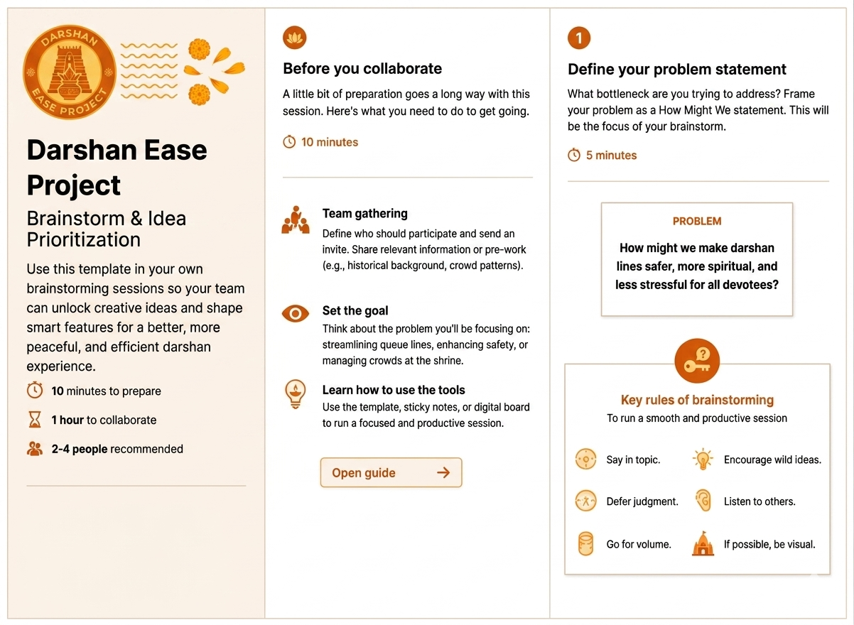

Step-2: Brainstorm, Idea Listing and Grouping
During the brainstorming session, our team discussed several ideas for the DARSHAN EASE project. We identified features such as Secure User Registration and Login, Role-Based Access (Devotee and Admin), Temple Listing with Images and Details, Temple Search and Filter, Darshan Slot Availability, Online Darshan Ticket Booking, Secure Online Payment Integration, Digital Ticket Generation with QR Code, Booking History, Booking Cancellation, Temple Information Management, Admin Dashboard, Profile Management, Email and SMS Booking Notifications, Responsive User Interface, JWT-based Authentication and Authorization, and Real-Time Slot Management. These ideas were grouped according to their functionality and prioritized to finalize the most essential features for the successful development of the project. The final solution aims to provide devotees with a seamless, secure, and convenient online darshan booking experience while enabling temple administrators to efficiently manage bookings, slots, and temple information.

.

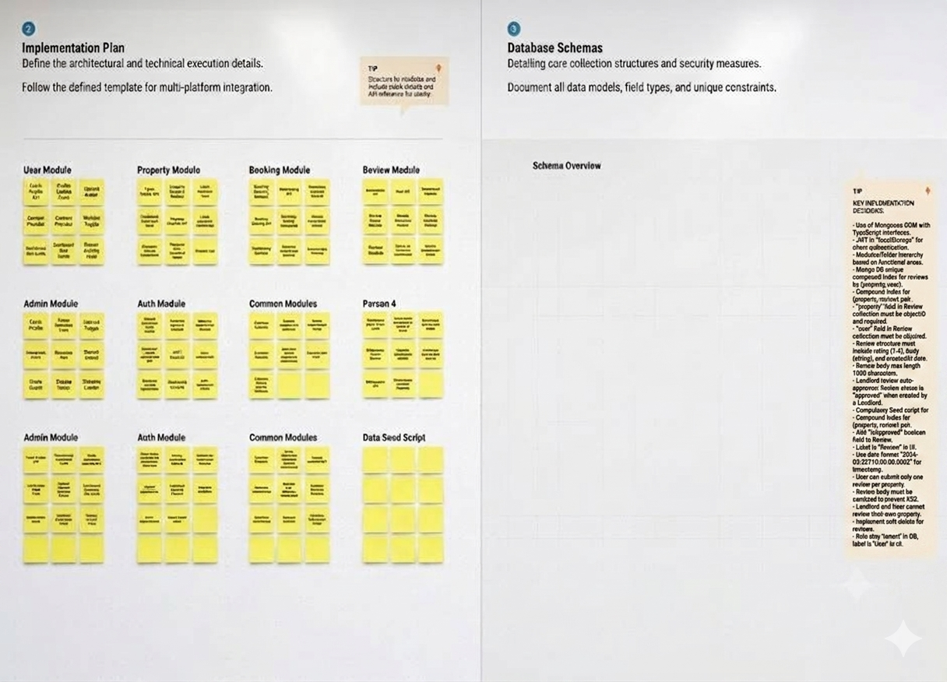

Step-3: Idea Prioritization
Secure User Authentication – Impact: High | Feasibility: High | Priority: Very High
Temple Listing & Management – Impact: High | Feasibility: High | Priority: Very High
Temple Search & Filters – Impact: High | Feasibility: High | Priority: Very High
Darshan Slot Booking System – Impact: High | Feasibility: High | Priority: Very High
Online Payment Integration – Impact: High | Feasibility: Medium | Priority: High
Admin Dashboard – Impact: High | Feasibility: Medium | Priority: High
Digital Ticket Generation (QR Code) – Impact: High | Feasibility: Medium | Priority: High
Booking History & Cancellation – Impact: Medium | Feasibility: High | Priority: Medium
Email/SMS Notifications – Impact: Medium | Feasibility: Medium | Priority: Medium
Responsive User Interface – Impact: Medium | Feasibility: High | Priority: Medium
JWT-based Authentication & Authorization – Impact: High | Feasibility: High | Priority: Very High
Temple Analytics & Reports – Impact: Medium | Feasibility: Medium | Priority: Medium
